St Edmund’s Hall, Hoxne
Cinema Equipment
User Guide
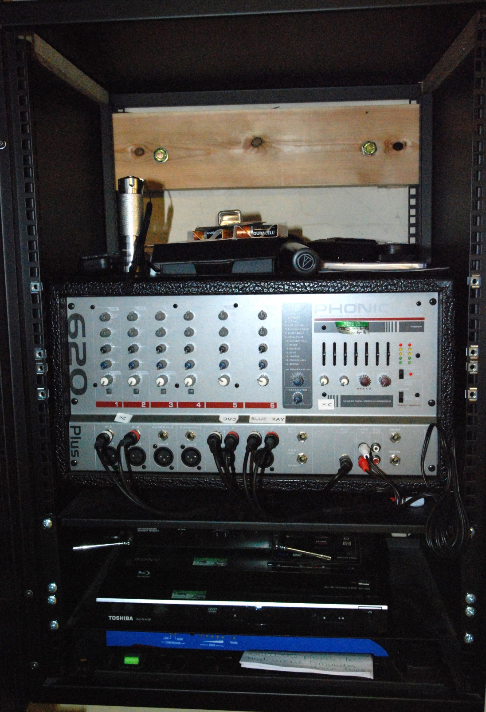
POWER SWITCH
MIC RECEIVER
HEARING LOOP
BLUE RAY PLAYER
DVD PLAYER
AMPLIFIER
- Precautions
- Basics
- Operating the Screen
- Operating the Projector
- Playing the Blue-Ray or DVD
- Projecting from a lap-top
- Sound
- Microphone
- Hearing Loop
- Film Night Check List

- PRECAUTIONS
- Ensure that the stage is clear before lowering the screen
- At the end of the event, turn the projector off first using the remote. While you clear up other items, this will allow time for it to cool down. Never turn off the power switch until the projector has been turned off for several minutes.
- Do not tap the microphone to check that it is working or use it when eating or drinking. These can damage it.
To sound check, speak normally and adjust amplifier as needed.
- The projector remote is a laser and can damage eyesight if pointed at a person. Only use it when pointed at the projector in the roof.
- Please ensure that all remotes and other equipment is tidied away in the box at the end, particularly laptop connection cables. Notify the Bookings Clerk of any difficulties that you have had.
- FIRST STEPS
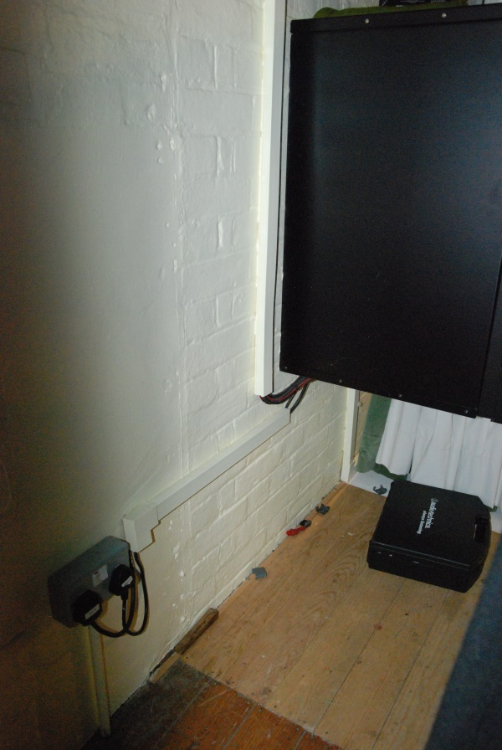

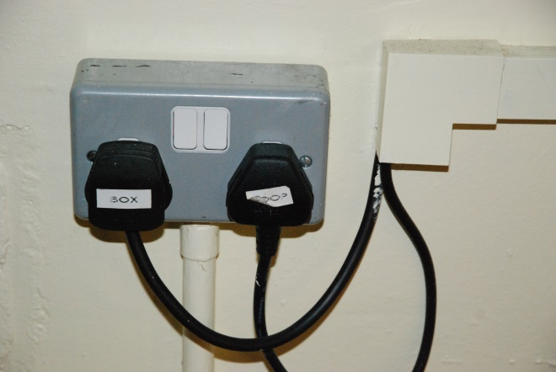

To power up the system, turn on the plug labelled LOOP to the left of the Control Box (alternatively, simply turn on both plugs).

Next, turn on the green switch that is part of the gang plug at the bottom left of the Control Box.

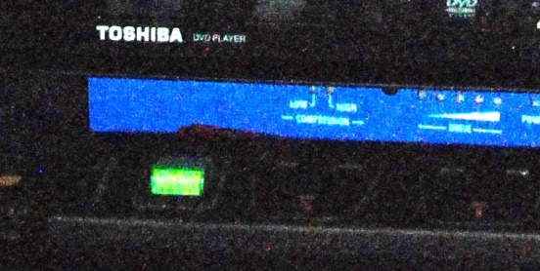

- OPERATING THE SCREEN
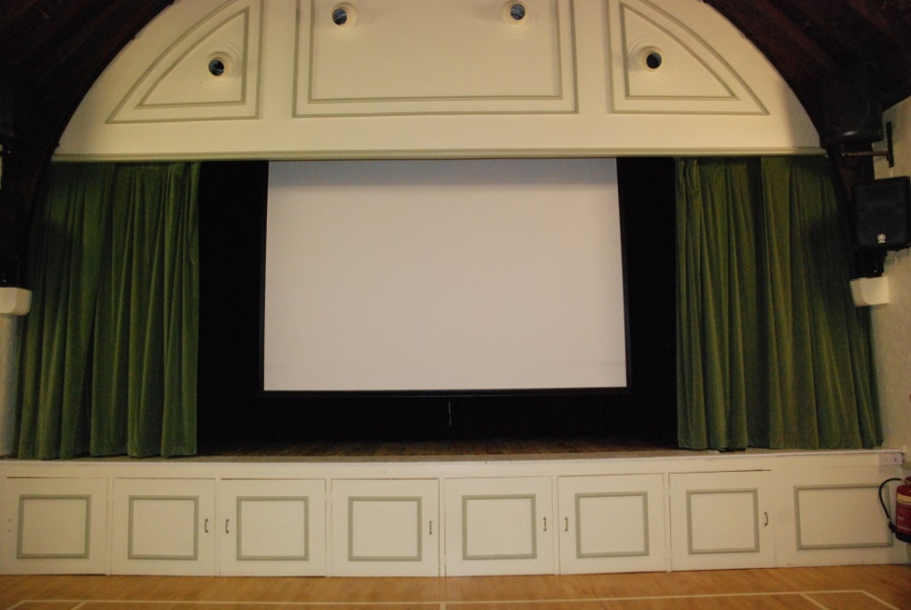
The screen, mounted above the stage, is electrically operated using a hand remote shown below. The screen will automatically stop at its lowest point, just above the stage or at the top when being put away. With the remote, you can fine tune the height to suit the film or other item being shown.
Ideally, close the black stage curtains behind the screen and partially close the main stage curtains as shown to focus the audience.
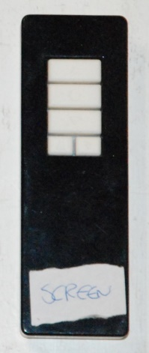
Down
Up
Stop
Nudge Up
Nudge down

MAKE SURE THAT THE STAGE IS CLEAR OF PEOPLE OR OTHER OBSTACLES BEFORE LOWERING THE SCREEN

- OPERATING THE PROJECTOR
The projector hangs from a ceiling beam in the Hall, receiving power and signals from the box. It is controlled using a laser remote control, which must be pointed at the projector to work (and NOT anywhere else as there is risk of eye damage if pointed at people).

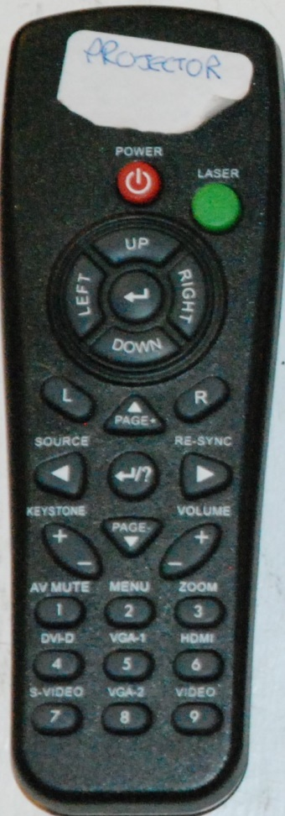
To turn on, press and hold the red power button until you see a white spot appear in the projector.
The projector will often find your source automatically after a few seconds. To choose your source in advance, point and press:
Blue-Ray 6 HDMI
Laptop 8 VGA–2
DVD 9 VIDEO
You can blank the screen at any time using button 1 AV MUTE (and reverse by pressing this button again)

To adjust picture position and other qualities, use the options in the main menu (button 2). Options will be displayed on the main screen.

REMEMBER TO ALLOW THE PROJECTOR TO COOL AND THE FAN TO STOP BEFORE TURNING OFF THE POWER IN THE CONTROL BOX

- PLAYING THE BLUE-RAY OR DVD

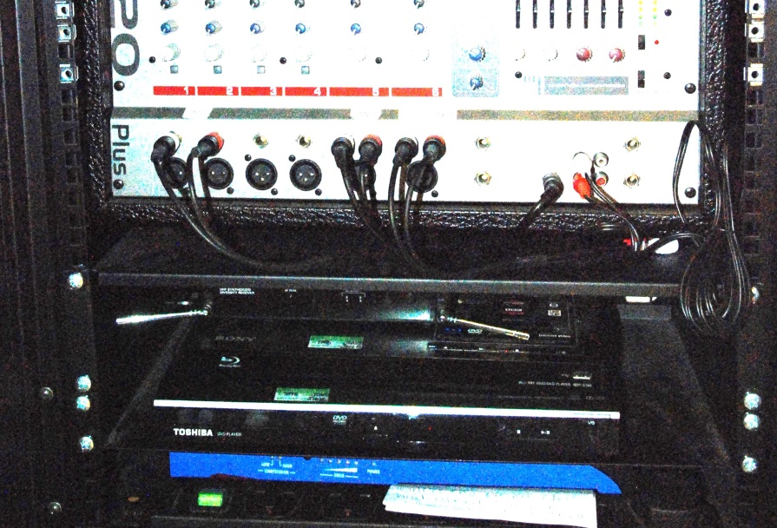
MIC RECEIVER
HEARING LOOP
DVD PLAYER
BLUE RAY PLAYER

The Blue-Ray is the normal way to go; the DVD is back-up only (and cannot play Blue-Ray discs). Both are standard equipment that you would have at home.
The remote must be pointed at the player.
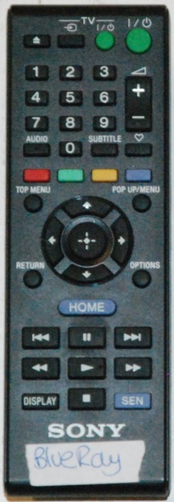
To project your image, use the projector remote – for Blue-Ray 6 HDMI, for DVD 9 VIDEO (see Operating the Projector for more info).
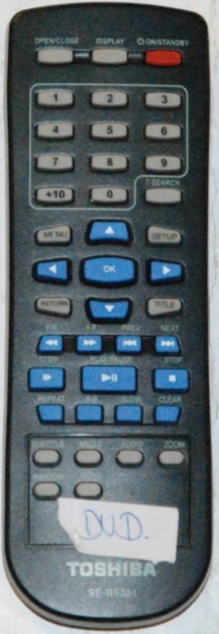
Blue-Ray DVD
- PROJECTING FROM A LAPTOP
Laptops can be connected to the projector using a VGA cable that is kept in the box. The projector becomes the monitor for the laptop. If sound is needed, this can be connected with jack plug, also in the box.
The laptop will often detect the connection and the screen will show the laptop page automatically. If not, you will need to instruct the laptop; this is often using function keys – F2 or F8 are common but this is PC specific. You may also have to use Control Panel to adjust the size of the image projected.
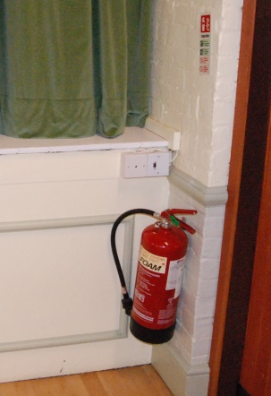
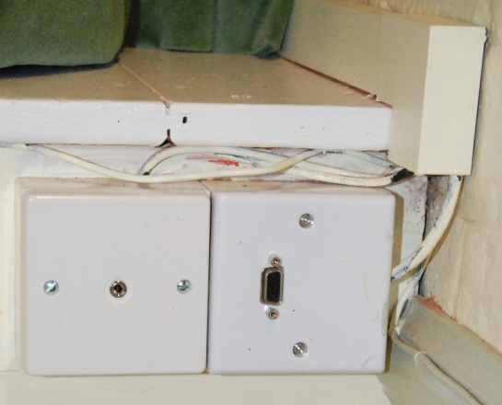

To set up
- Plug power to the laptop, if needed, using the gang plug at the bottom of the box
- Connect the laptop to the system using the VGA cable to the right-hand socket on the edge of the stage
- Connect the sound to the left-hand socket using the 3.5mm jack plug, the laptop end is normally the headphone socket
- If not picked up automatically by the projector, select the source as 2 VGA
- IPOD/MP3 Sound only
- To play music or any sound only, connect the jack plug cable to your device and the plug, adjust sound level using the amplifier (see Sound page)
- SOUND
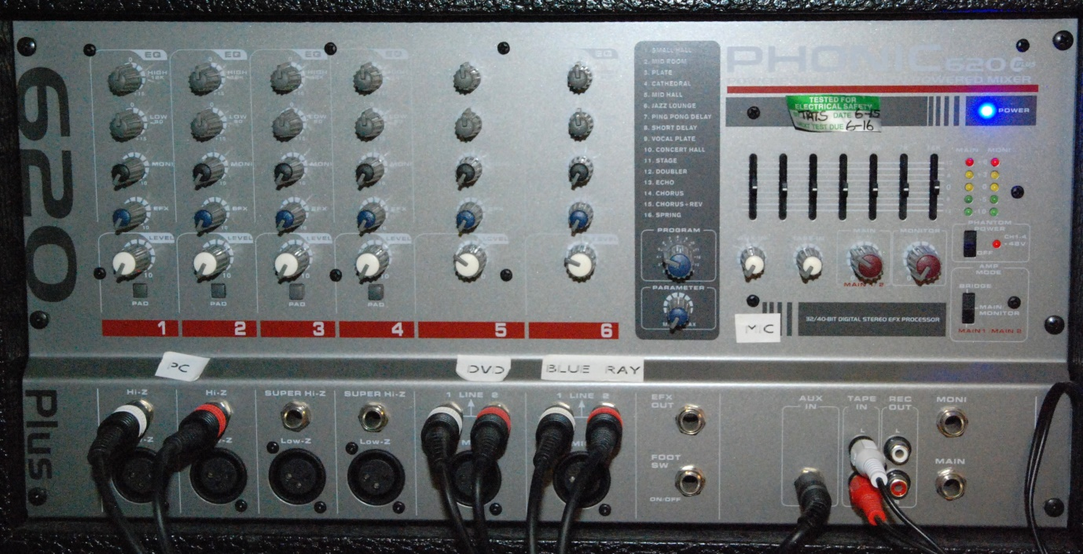
A
C
B
F
G
E
D
B
A

The sound system is very versatile and unless you are experienced, you should leave settings as standard, as below:
- Standard 12o/c
- Standard 7o/c
- Special effects, standard 5 Mid Hall
- Adjustments for equipment being used (if using two, they may require different settings).
- Plugs should not be removed, especially when power is on as it could cause damage to equipment
- Main sound level adjustment
- Microphone sound level control

- MICROPHONE
The radio microphone system is in two parts, the Receiver in the control box and the hand microphone that can be used anywhere in the Main Hall. The hand microphone is powered by two AA batteries – spare batteries are in the control box, to replace unscrew the handle.
The on/off/mute button is on the bottom of the microphone;
- To turn on, press this once for 2-3 seconds; a green light will appear. The microphone is now working
- To mute the microphone, tap the button again; a red light will appear. To un-mute tap the button again and the green light will return.
- To turn off, press the button for 2-3 seconds and the light will go off.

Volume can be adjusted on the amplifier see G on the Sound guide.
WARNING: THE MICROPHONE MUST BE KEPT MORE THAN TWO METRES AWAY FROM THE SPEAKERS unless great care is taken to avoid feedback (loud SCREAMING). If this does happen, move away quickly and then turn down the sound level on the amplifier to prevent a repeat.

NEVER TAP THE TOP OF THE MICROPHONE TO SEE IF IS WORKING – THIS WILL DAMAGE IT.
You can tell if it is working by talking into it

- HEARING LOOP

The hearing loop is working as soon as the power switch on the wall plug is turned on, the system is totally automatic and needs no setup or adjustment. Simply advise people who wish to listen to the hearing loop to select the ‘T’ setting on their hearing aids.

Please be aware that National Health hearing aids work best with this type of equipment as they have physically large enough aerials. Totally in-ear hearing aids despite being very expensive are not always constructed to fully meet the national standards and as such may have disappointing performance with the loop. Performance of the magnetic loop is also affected by metal work in the structure of the building and as such it is advisable for anyone using a hearing aid to select a seat for the show in the areas that give best reception for that user.
PLEASE NOTE that the ceiling-level microphones for the hearing loop are always on when the hearing loop is powered and as such ANY sounds or CONVERSATIONS will be heard and transmitted via the loop.

- FILM NIGHT CHECK LIST – Print a copy to use on the night from website
Presenting the film is stressful. Make sure that you arrive in good time and, if possible, find somebody to help.
Before arrival:
- Ensure you have the film DVD. If possible, identify the film break point.
- Check that any files to be shown where you can find them in your PC
- Prepare the points that you want to make at the introduction
On arrival:
- Open the box – obtain the key in advance (spare behind bar if needed).
- Check the equipment, particularly that the amplifier settings are on standard (7 SOUND) and that the four remotes and PC & jack plug cables are present.
- Set up table & chair in front of box to work on when backstage
- Turn on the equipment – plugs in wall, green button bottom of box.
- Lower the screen – ensure area if clear. Power up projector
- Identify the film break point if not done in advance using the DVD player, which has a timer [9-Video on the projector remote]
- Connect up the PC and check that slides play correctly [8-VGA] and sound check if necessary [7 Sound – D knobs]
- Sound check on the Blue-Ray player; two-person if possible [6-HDMI]. Note below the sound control knob level and then return to mute. [7 Sound – D]. Leave Blue-Ray paused at the starting point you wish.
THE SHOW
Sound knob levels
Main (F) Blue-Ray (D) PC (D)

Before the film
- Set the slides looping on the PC
- Projector to [8-VGA]
- When ready to start film
  - Turn PC sound knobs to mute
  - Blank the screen [1-AV MUTE]
  - Stop the PC slides
  - Turn Blue-Ray sound knob to pre-determined level
- Give introduction, remembering the Health & Safety remarks
Starting the film
- Projector to [6-HDMI]
- Resume Blue-Ray on remote

Interval
- Pause the Blue-Ray on remote II
- Blank the screen [1-AV MUTE]
- If PC slides have sound, turn Blue-Ray sound knob to mute and PC to pre-determined level
- Start slides running on PC and Projector to 8-VGA

Restarting the film
- When ready to start film
  - Blank the screen [1-AV MUTE]
  - Stop the PC slides
  - Turn PC sound knobs to mute, if necessary
  - Turn Blue-Ray sound knob to pre-determined level
- Ask audience for help to stack the chairs at the end of the performance
- Projector to [6-HDMI]
- Resume Blue-Ray on remote

Closing down
- Turn off the projector first [Power button on remote] to allow time to cool – the Red light on the projector will stop flashing (only visible when standing under it in the hall).
- Remove disc from Blue-Ray player
- Raise screen
- Replace all equipment into box (remember PC cables)
- After sufficient time for the projector, turn off the green switch on the gang plug and lock box
- Turn off switches on wall
- Tidy up and put away your PC
- Go to the pub for a welcome drink

